Mineral Mining Incorporated

Environmental Impact Statement: Limestone Quarry

Proposal:

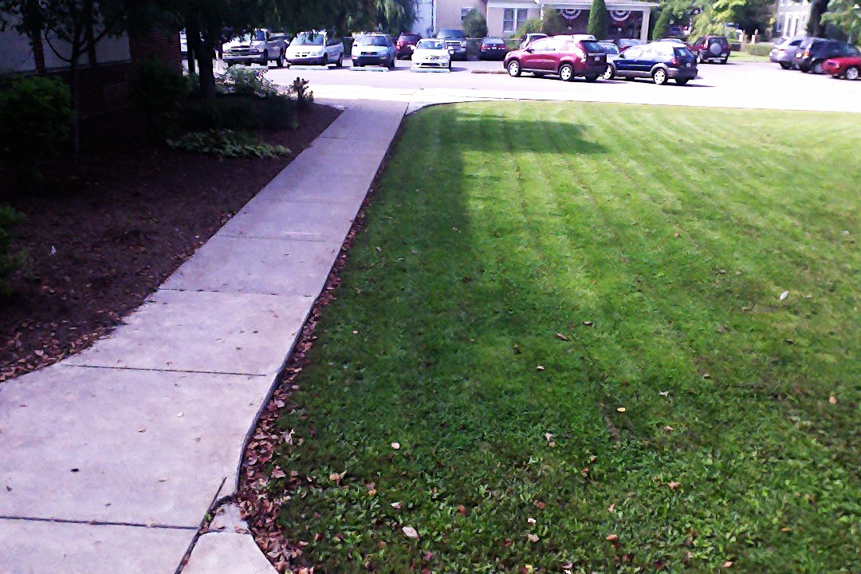Mineral Mining Incorporated (MMI) wishes to open a new limestone quarry in Lewisburg, Pennsylvania. The quarry is needed to the limestone needs of individuals, businesses, and the borough. Limestone, a sedimentary rock, is used in creating driveways and roads as well as to neutralize acidic soil. Many buildings and other architectural structures also contain limestone. Furthermore, this sedimentary rock is present in household items such as carpet, glass, toothpaste, and cleaning products. Finally, we consume limestone on a daily basis through our drinking water as well as sugar. Therefore, MMI believes that it would be beneficial to everyone to make use of the natural resource that is present under downtown Lewisburg.

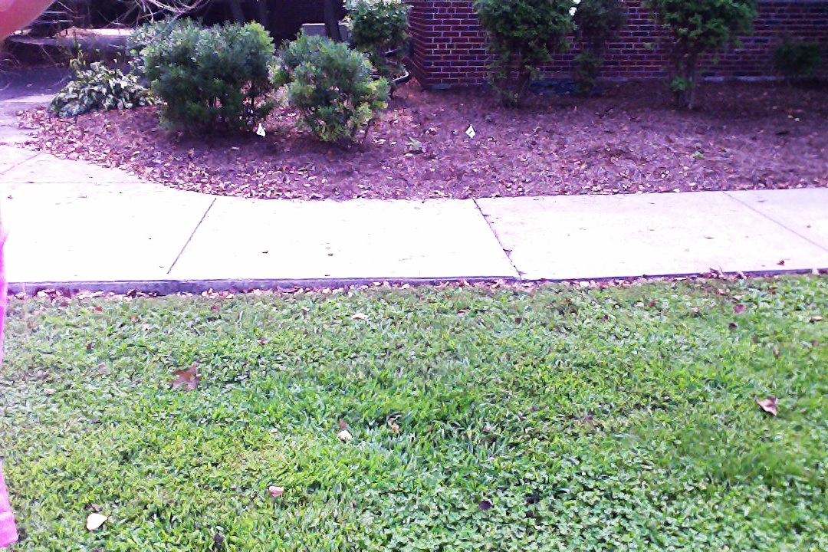 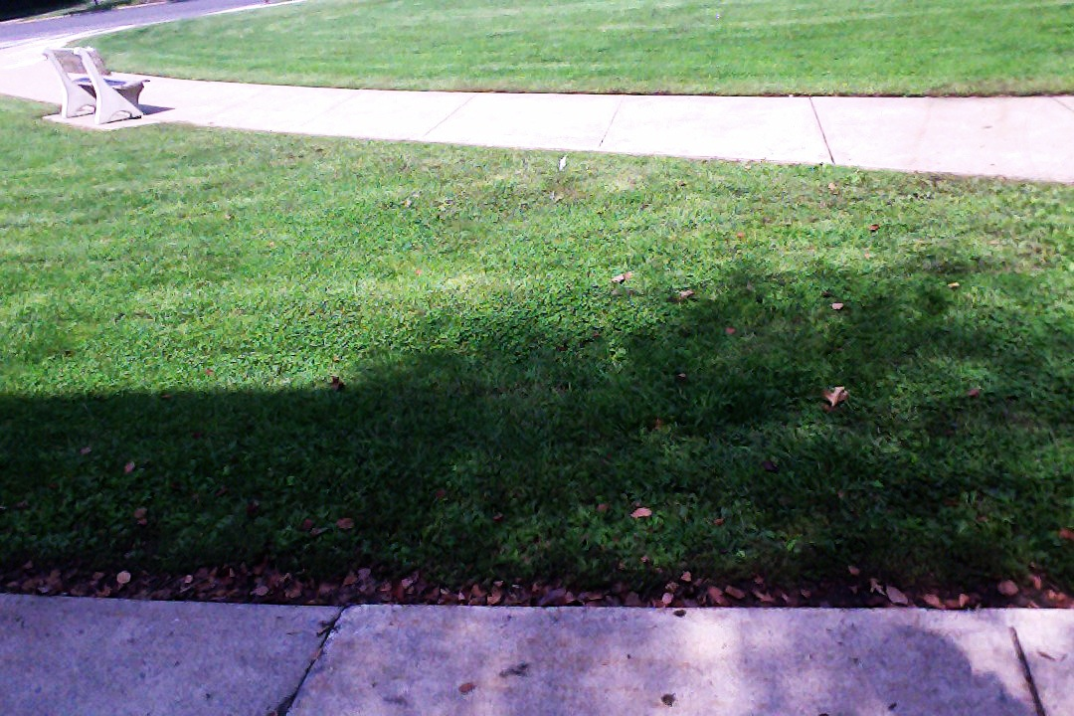

Map of Proposed Site: 2,295 acres

B

A

|  |  |  |  |  |  |  |  |  |  |  |  |  |  |  |  |  |  |  |  |
| --- | --- | --- | --- | --- | --- | --- | --- | --- | --- | --- | --- | --- | --- | --- | --- | --- | --- | --- | --- |
|  |  |  |  |  |  |  |  |  |  |  |  |  |  |  |  |  |  |  |  |
|  |  |  |  |  |  |  |  |  |  |  |  |  |  |  |  |  |  |  |  |
|  |  |  |  |  |  |  |  |  |  |  |  |  |  |  |  |  |  |  |  |
|  |  |  |  |  |  |  |  |  |  |  |  |  |  |  |  |  |  |  |  |
|  |  |  |  |  |  |  |  |  |  |  |  |  |  |  |  |  |  |  |  |

C

D

Scale

1 mile

|  |  |  |  |  |  |  |  |  |  |
| --- | --- | --- | --- | --- | --- | --- | --- | --- | --- |
|  |  |  |  |  |  |  |  |  |  |

10,000 ft.

Key

Forest

Development

Farmland



|  |
| --- |
|  |

|  |
| --- |
|  |

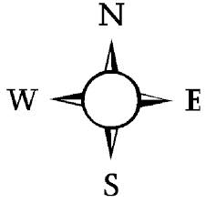

|  |
| --- |
|  |

C: Elevation – 468 ft.

Latitude – 40° 57.636’

Longitude – 76° 53.456’

D: Elevation – 477 ft.

Latitude – 40° 57.634’

Longitude – 76° 53.455’

A: Elevation – 469 ft.

Latitude - N 40° 57.637’

Longitude - HO 76° 53.456’

B: Elevation – 470 ft.

Latitude – N 40° 57.634’

Longitude – HO 76° 53.456’

Table of Contents

Section I: Land Usage

1. Current Land Use
2. Farmland
3. Development/Communities
4. Forests

2. Historical Use

3. Future Land Use Possibilities

a. Farmland

b. Development

Section II: Environmental Hazards

1. Habitat Destruction

1. Endangered Species

a. Indiana Bat

b. Bog Turtle

3. Air Pollution

1. Water Pollution

5. Federal Regulations

Section III: Affects on the Community

1. Noise Levels

1. Financial Benefits

3. Financial Losses

Section IV: Alternate Options

1. Other Possible Locations

Section I: Land Usage

1. Current Land Usage

The 2,295 acre plot of land MMI has chosen for their new quarry is located on the edge of the borough. The land where the proposed quarry will go is currently:

a. Farmland – Several local farmers currently use the southern 344 acres to plant crops such as soybeans and corn. These fields produce a total of 200 to 400 pounds of food per acre annually.

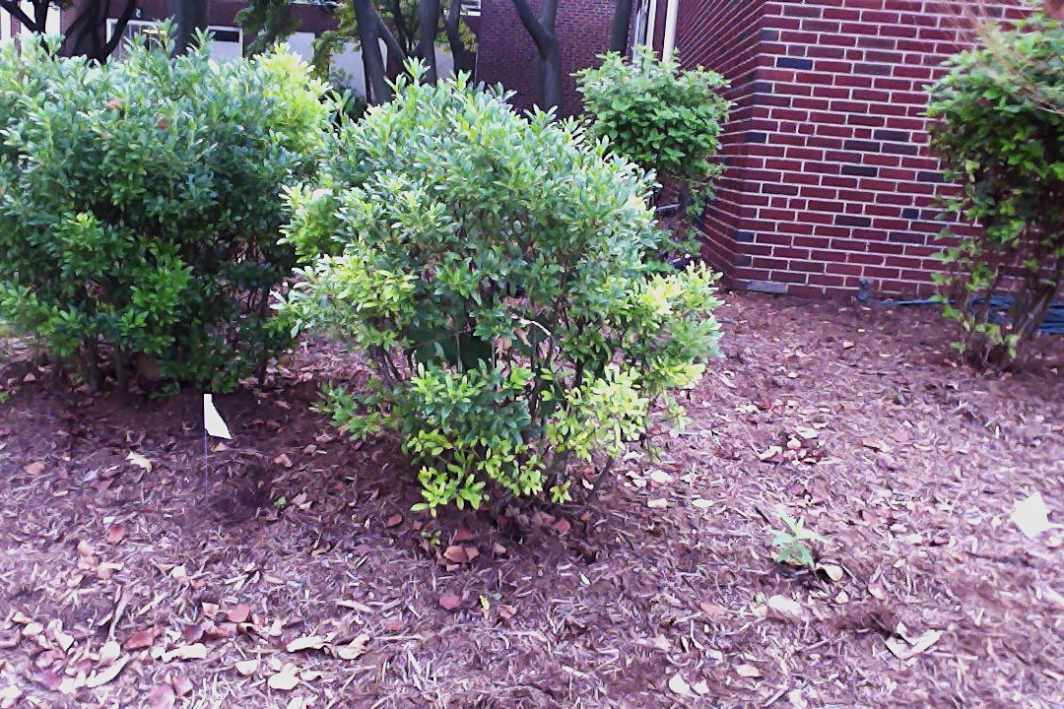

b. Development /Communities - The 573 acres that are between the fields in the south and the forest in the north is mostly developments. Approximately 4,500 people currently live on this plot of land.

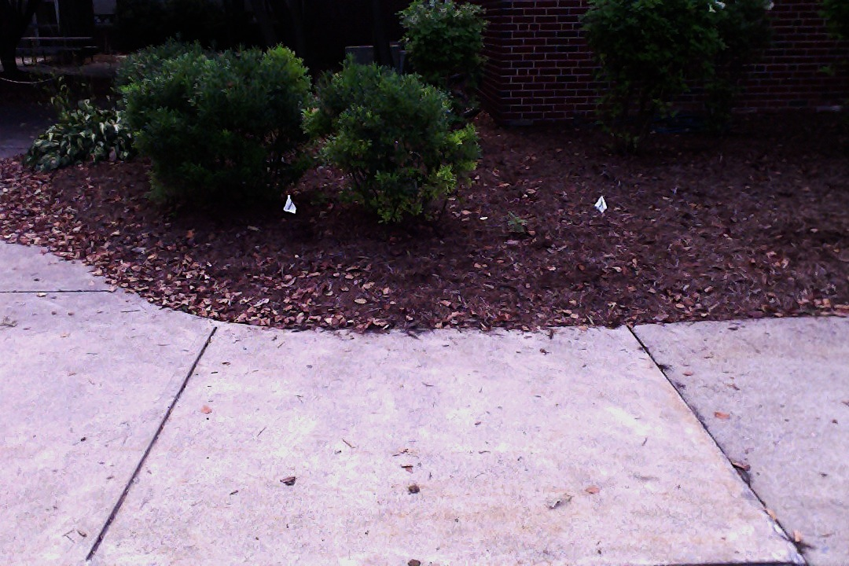

c. Forest – The deciduous forest that makes up the most of the proposed quarry site is home to many of the organisms that are native to Pennsylvania. The limestone quarry would take up 1,377 acres of forest.

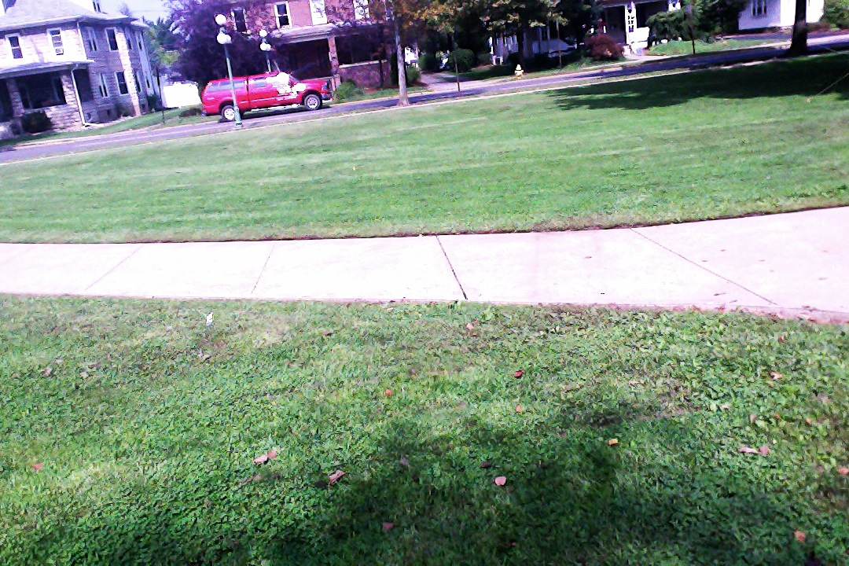

1. Historical Use

The Lewisburg High School was built in 1928 and generations of students have walked its halls. The quarry project would demand that the high school be torn down, so that former students would never be able to revisit their old school. Furthermore, Lewisburg has many historic buildings that have authentic architecture from different time periods. The limestone quarry would indirectly affect these buildings through pollution and detracting from the general beauty.

1. Future Land Use

After MMI has mined all of the limestone available on the proposed site, the land will have to be used for something else. Because the site is close to downtown Lewisburg, the quarry needs to be returned to something else so that the residents of the small town will not be at risk. Furthermore, quarries can be seen from far away, so it would affect the town’s idyllic image if the quarry were to be left as is after project conclusion.

1. Farming – Returning the land to fields would not be the optimal choice because the soil composition will have been disrupted from the mining. Furthermore, the land will no longer be relatively flat, and it would take a great deal of time and effort to get it back to terrain that would be suitable to farm on.
2. Development – To return the proposed quarry site back into housing after the project is finished would be an expensive and time-consuming venture. If somebody wished to do this they would have to level the site and make sure that there would be no possibility of sink holes. Then, all of the houses would have to be rebuilt, so their would still be construction going on several years after the quarry project had reached completion.

Section II: Environmental Hazards

1. Habitat Destruction

If the limestone quarry project is put into action, hundreds of acres of deciduous forest will have to be logged and forested. This will displace many native animals such as squirrels, owls, chipmunks, and more. Furthermore, it will affect the biodiversity of the ecosystems in the immediate and surrounding area.

1. Endangered Species

a. Indiana Bat - The Indiana bat hibernates in cool caves during the winter and roosts in colonies in cracks or crevices in the summer. They are endangered because people disturb their winter caves. Other causes are loss of summer habitats, pesticides, and the disease known as white nose syndrome.

b. Bog Turtle - The bog turtle is the smallest turtle in North America at only four inches long. This tiny turtle lives in sunny wetlands and is endangered due to the loss and destruction of its habitat.

1. Air Pollution

The quarrying for limestone will cause an excessive amount of limestone dust as well as increased exhaust from the extra traffic to be released into the air. This increased air pollution cannot only affect humans with respiratory issues but also be detrimental to the environment. The dust can harm plants by clogging their veins as well as damaging their internal structures.

1. Water Pollution

If MMI goes through with the quarry project, it will produce a lot of waste, such as sand and silt. This solid waste can contaminate the water sources, which can then lead to imbalances in the freshwater ecosystems. Furthermore, the excess sand and silt can cause flooding if produced in large amounts.

If MMI builds a quarry on the proposed site the following streams and rivers, as well as various ponds, will be affected by the pollution generated by the quarry and the mining process:

* West Branch Susquehanna River
* Limestone Run
* Miller Run
* Mill Race
* Buffalo Creek

1. Federal Regulations

MMI will have to make sure that they follow several federal regulations that help to keep the environment healthy. Some of the regulations that will be relevant for the limestone quarry are the following:

* Surface Mining Control and Reclamation Act of 1977
* Endangered American Wilderness Act of 1978
* National Forest Management Act of 1976
* Federal Land Policy and Management Act of 1976
* Noise Control Act of 1965
* Quiet Communities Act of 1978
* Soil Conservation Act of 1935
* Clean Water Act of 1972
* Species Conservation Act of 1966
* Endangered Species Act of 1973

Section III: Effects on the Community

1. Noise Levels

Currently, the noise levels at the proposed site are relatively quiet. There is some noise coming from the traffic of neighboring Route 15 and Market Street, but otherwise it is a quiet neighborhood. If the quarry is approved, the noise levels on and around the site will go up considerably. This is because the process of extracting limestone is a very noisy one, and the traffic around the site will go up due to all of the worker’s can construction vehicles.

1. Financial Benefits

The community will financially benefit from the quarry in a couple of ways. First of all there will be an increase of jobs due to all of the workers needed to complete the project. Second, people will be able to buy their limestone locally eliminating extra costs that they might have had to pay if they had to buy their limestone from somewhere farther away. Finally, the quarry will help the Lewisburg Borough financially by bringing new people in to work on the quarry and selling the limestone. The company will be able to sell about $13,200,000,000 of limestone if they sell it for $22 a ton.

1. Financial Losses

The limestone quarry will be an eyesore both during and after the project. Quarries are visibly from far away and visitors to the town will not appreciate having to look and deal with a quarry during the visit.

Section IV: Alternate Options

1. Other Possible Sites

The company has looked at an alternative site for the quarry located farther out in the country. This site is farther away from the town center and will avoid a large amount of people having to move. However, it would take away more farmland and there would have to be many access roads built in order to make it easily accessible.